The Introduction of Shaitan
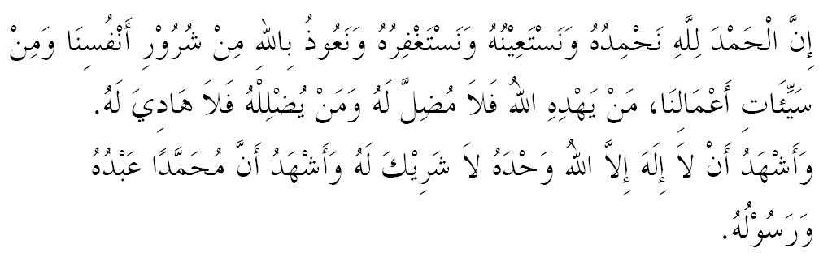
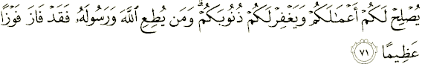

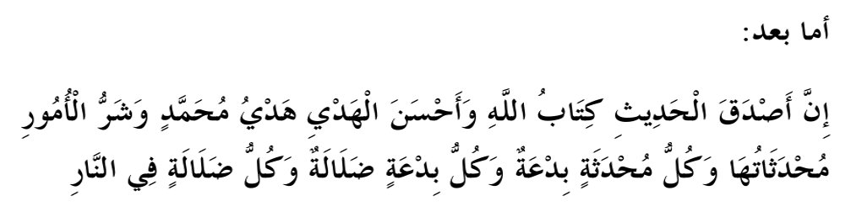

The word(s) "Shaitan" appears 95 time(s) in 83 verse(s) in Quran in Muhammad Habib Shakir translation.
Shaitan Begins
وَإِذۡ قُلۡنَا لِلۡمَلَـٰٓٮِٕكَةِ ٱسۡجُدُواْ لِأَدَمَ فَسَجَدُوٓاْ إِلَّآ إِبۡلِيسَ أَبَىٰ وَٱسۡتَكۡبَرَ وَكَانَ مِنَ
ٱلۡكَـٰفِرِينَ (﻿٣٤﻿)
And when We said to the angels: Make obeisance to Adam, they did obeisance, not so Iblis, he refused and was haughty and he was of the rejecter." (Quran 2:34)

He Argued:
قَالَ أَنَا۟ خَيۡرٌ۬ مِّنۡهُ‌ۖ خَلَقۡتَنِى مِن نَّارٍ۬ وَخَلَقۡتَهُ ۥ مِن طِينٍ۬ (﻿٧٦﻿

I am better than him, You created me from fire, but you created him from clay
(﻿٣٨﻿) قَالَ رَبِّ بِمَآ أَغۡوَيۡتَنِى لَأُزَيِّنَنَّ لَهُمۡ فِى ٱلۡأَرۡضِ وَلَأُغۡوِيَنَّہُمۡ أَجۡمَعِينَ (﻿٣٩﻿)
O my Lord! because you have put me in the wrong, I will make (wrong) fair-seeming to them on the earth, and I will put them all in the wrong―
Open Enemy
يَـٰٓأَيُّهَا ٱلنَّاسُ كُلُواْ مِمَّا فِى ٱلۡأَرۡضِ حَلَـٰلاً۬ طَيِّبً۬ا وَلَا تَتَّبِعُواْ خُطُوَٲتِ ٱلشَّيۡطَـٰنِ‌ۚ إِنَّهُ ۥ لَكُمۡ عَدُوٌّ۬ مُّبِينٌ (﻿١٦٨﻿)
O men! eat the lawful and good things out of what is in the earth, and do not follow the footsteps of theShaitan; surely he is your open enemy.
ـٰٓأَيُّهَا ٱلَّذِينَ ءَامَنُواْ ٱدۡخُلُواْ فِى ٱلسِّلۡمِ ڪَآفَّةً۬ وَلَا تَتَّبِعُواْ خُطُوَٲتِ ٱلشَّيۡطَـٰنِ‌ۚ إِنَّهُ ۥ لَڪُمۡ عَدُوٌّ۬ مُّبِينٌ۬ (﻿٢٠٨﻿
O you who believe! enter into submission one and all and do not follow the footsteps of Shaitan; surely he is your open enemy.

Guardian of Darkness
ٱللَّهُ وَلِىُّ ٱلَّذِينَ ءَامَنُواْ يُخۡرِجُهُم مِّنَ ٱلظُّلُمَـٰتِ إِلَى ٱلنُّورِ‌ۖ وَٱلَّذِينَ كَفَرُوٓاْ أَوۡلِيَآؤُهُمُ ٱلطَّـٰغُوتُ يُخۡرِجُونَهُم مِّنَ ٱلنُّورِ إِلَى ٱلظُّلُمَـٰتِ‌ۗ أُوْلَـٰٓٮِٕكَ أَصۡحَـٰبُ ٱلنَّارِ‌ۖ هُمۡ فِيہَا خَـٰلِدُونَ (﻿٢٥٧﻿)
Allah is the guardian of those who believe. He brings them out of the darkness into the light; and (as to) those who disbelieve, their guardians are Shaitans who take them out of the light into the darkness; they are the inmates of the fire, in it they shall abide.
He threatens
ٱلشَّيۡطَـٰنُ يَعِدُكُمُ ٱلۡفَقۡرَ وَيَأۡمُرُڪُم بِٱلۡفَحۡشَآءِ‌ۖ وَٱللَّهُ يَعِدُكُم مَّغۡفِرَةً۬ مِّنۡهُ وَفَضۡلاً۬‌ۗ وَٱللَّهُ وَٲسِعٌ عَلِيمٌ۬ (﻿٢٦٨﻿)
Shaitan threatens you with poverty and enjoins you to be niggardly, and Allah promises you forgiveness from Himself and abundance; and Allah is Ample-giving, Knowing.

He scares
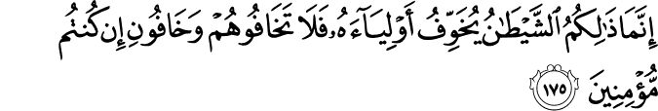
It is only Shaitan (Satan) that suggests to you the fear of his Auliya' [supporters and friends (polytheists, disbelievers in the Oneness of Allah and in His Messenger, Muhammad SAW)], so fear them not, but fear Me, if you are (true) believers.
He Tricks
فَلَوۡلَآ إِذۡ جَآءَهُم بَأۡسُنَا تَضَرَّعُواْ وَلَـٰكِن قَسَتۡ قُلُوبُہُمۡ وَزَيَّنَ لَهُمُ ٱلشَّيۡطَـٰنُ مَا ڪَانُواْ يَعۡمَلُونَ (﻿٤٣﻿)
Surah Al-Anaam
If only, when Our disaster came on them, they had been humble! But their hearts were hardened and the devil made all that they used to do seem fair unto them! (43)

He makes false promises
He [Shaitan (Satan)] makes promises to them, and arouses in them false desires; and Shaitan's (Satan) promises are nothing but deceptions.
He Creates Chaos
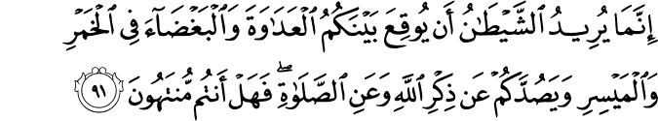
Shaitan (Satan) wants only to excite enmity and hatred between you with intoxicants (alcoholic drinks) and gambling, and hinder you from the remembrance of Allah and from As-Salat (the prayer). So, will you not then abstain?

Satan’s ultimate goal

قَالَ فَبِمَآ أَغۡوَيۡتَنِى لَأَقۡعُدَنَّ لَهُمۡ صِرَٲطَكَ ٱلۡمُسۡتَقِيمَ (﻿١٦﻿) ثُمَّ لَأَتِيَنَّهُم مِّنۢ بَيۡنِ أَيۡدِيہِمۡ وَمِنۡ خَلۡفِهِمۡ وَعَنۡ أَيۡمَـٰنِہِمۡ وَعَن شَمَآٮِٕلِهِمۡ‌ۖ وَلَا تَجِدُ أَكۡثَرَهُمۡ شَـٰكِرِينَ (﻿١٧﻿
(Iblîs) said: "Because You have sent me astray, surely I will sit in wait against them (human beings) on Your Straight Path (16) Then I will come to them from before them and behind them, from their right and from their left, and You will not find most of them as thankful ones (i.e. they will not be dutiful to You)." (17)
Close Friends of Shaitan

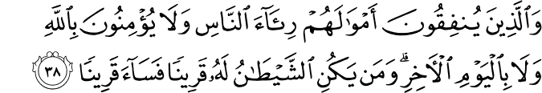
And (also) those who spend of their substance to show people, and believe not in Allah and the Last Day [they are the friends of Shaitan (Satan)], and whoever takesShaitan (Satan) as an intimate; then what a dreadful intimate he has!

Allah’s Advice to Children of Adam
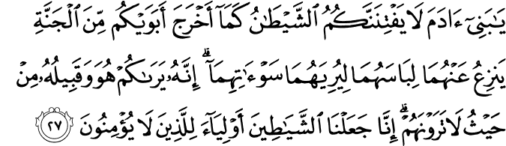
O Children of Adam! Let not Shaitân (Satan) deceive you, as he got your parents [Adam and Hawwa (Eve)] out of Paradise, stripping them of their clothing, to show them their private parts. Verily, he and Qabîluhu (his soldiers from the jinn or his tribe) see you from where you cannot see them. Verily, We made the Shayâtin (devils) Auliyâ' (protectors and helpers) for those who believe not. (27)
According to Ibn Al- Qayyim Rahimahullah
This attitude caused Iblis
- To be ejected from enjoying the company of angels to being debased and cursed
- To be distant from Allah after being close
- From being recipient of His mercy to being a recipient of his curse
- Fom being in Paradise to being condemned to the blazing fire
- From being beautiful to being ugly
- From being a believer to being a disbeliever
- From being the friend of Allah to being His greatest enemy
- From being a person devoted to the glorification of his Lord, to being a person of kufr, shirk, lies and shameful deeds
- He became completely worthless and insignificant in the sight of Allah, and the he became a leader of every sinner and criminal
O Allah we take refuge with you from opposing your command and taking on board your prohibition. Ameen
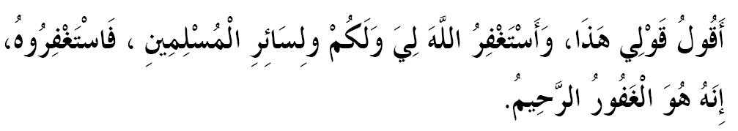

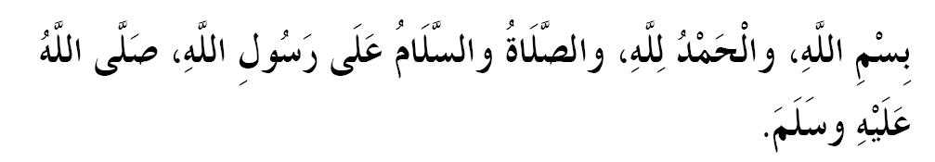
Shaitan's throne in the ocean
"Jabir reported: "I heard Allah's messenger as saying: "The throne of Iblis (Satan's name) is upon the ocean and he sends detachments in order to put people to trial and the most important figure in his eyes is the one who is most notorious in sowing the seed of dissension.""
He Challenges Allah
The Messenger of Allah (sal Allahu alaihi wa sallam) said: “The Shaytaan said, ‘By Your Glory and Majesty, I will never cease to misguide Your slaves so long as their souls remain in their bodies.’ The Lord said, ‘By My Glory and Majesty, I will continue to forgive them so long as they seek My forgiveness.’” [Ahmad]

Shaitan scared of the AZAAN
1.582: Narrated Abu Huraira:
Allah's Apostle said, "When the Adhan is pronounced Satan takes to his heels and passes wind with noise during his flight in order not to hear the Adhan. When the Adhan is completed he comes back and again takes to his heels when the Iqama is pronounced and after its completion he returns again till he whispers into the heart of the person (to divert his attention from his prayer) and makes him remember things which he does not recall to his mind before the prayer and that causes him to forget how much he has prayed."
SHAITAN eats and drinks with his LEFT HAND so dont do that!!
Ibn Umar reported Allah's messenger as saying, "When anyone of you intends to eat (meal), he should eat with his right hand, and when he (intends) to drink he should drink with his right hand, for the Satan eats with his left hand and drinks with his left hand."
When you sleep SHAITAN ties three knots to you!: Narrated Abu Huraira
Allah's Apostle said, "Satan puts three knots at the back of the head of any of you if he is asleep. On every knot he reads and exhales the following words, 'The night is long, so stay asleep.' When one wakes up and remembers Allah, one knot is undone; and when one performs ablution, the second knot is undone, and when one prays the third knot is undone and one gets up energetic with a good heart in the morning; otherwise one gets up lazy and with a mischievous heart."

Uses laziness and procrastination to keep one away from good deeds
Narrated 'Abdullah :
A person was mentioned before the Prophet and he was told that he had kept on sleeping till morning and had not got up for the prayer. The Prophet said, "Satan urinated in his ears."

When babys are Born, SHAITAN pokes them!!
Narrated Abu Huraira:
The Prophet said, "When any human being is born. Satan touches him at both sides of the body with his two fingers, except Jesus, the son of Mary, whom Satan tried to touch but failed, for he touched the placenta-cover instead."

Finally, at the end, whom do we blame and what will Satan say?

وَقَالَ ٱلشَّيۡطَـٰنُ لَمَّا قُضِىَ ٱلۡأَمۡرُ إِنَّ ٱللَّهَ وَعَدَڪُمۡ وَعۡدَ ٱلۡحَقِّ وَوَعَدتُّكُمۡ فَأَخۡلَفۡتُڪُمۡ‌ۖ وَمَا كَانَ لِىَ عَلَيۡكُم مِّن سُلۡطَـٰنٍ إِلَّآ أَن دَعَوۡتُكُمۡ فَٱسۡتَجَبۡتُمۡ لِى‌ۖ فَلَا تَلُومُونِى وَلُومُوٓاْ أَنفُسَڪُم‌ۖ مَّآ أَنَا۟ بِمُصۡرِخِڪُمۡ وَمَآ أَنتُم بِمُصۡرِخِىَّ‌ۖ إِنِّى ڪَفَرۡتُ بِمَآ أَشۡرَڪۡتُمُونِ مِن قَبۡلُ‌ۗ إِنَّ ٱلظَّـٰلِمِينَ لَهُمۡ عَذَابٌ أَلِيمٌ۬ (﻿٢٢﻿)
“And Shaitan (Satan) will say when the matter has been decided: ‘Verily, Allah promised you a promise of truth. And I too promised you, but I betrayed you. I had no authority over you except that I called you, and you responded to me. So blame me not, but blame yourselves. I cannot help you, nor can you help me. I deny your former act in associating me (Satan) as a partner with Allah (by obeying me in the life of the world). Verily, there is a painful torment for the Zaalimoon (polytheists and wrongdoers)’” (Quran, Ibraaheem: 22).
