KHUTBAH: Allah’s Beautiful Names.
By Salim Ebrahim.
Jurgens Centre, Englefield Green, Surrey. 2nd February 2018

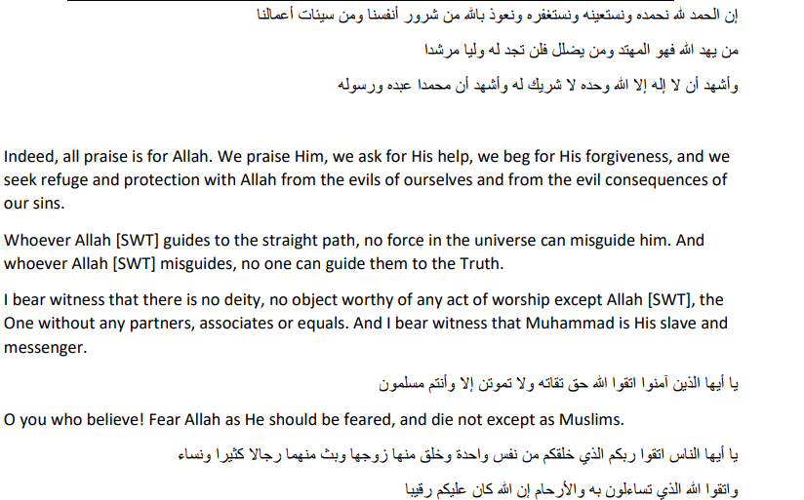
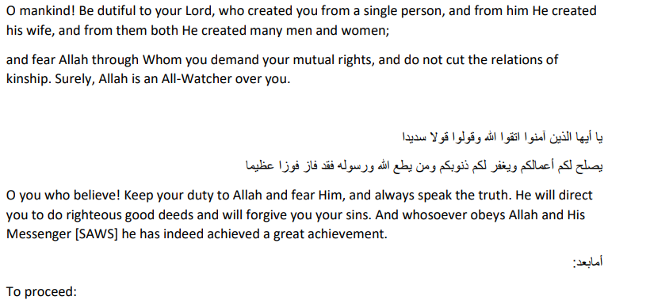
Today’s Khutbah is a continuation of the one started a while back about knowing & understanding Allah SWT from the Quraan and the Asma Ul Husnaa.
To recap, we said that we must have ideas of Allah SWT if we are to worship him, although to define our Rabb is utterly beyond human power.
We mentioned some of his beautiful names and what they mean. I intend to talk through some more of those names.
Surah Ikhlas – Say, He is One, The Eternal The Absolute, neither does He Beget nor is He Begotten and there is none like unto Him.
Ayatul Kursi –

Allah - there is no deity except Him, the Ever-Living, the Sustainer of [all] existence. Neither drowsiness overtakes Him nor sleep. To Him belongs whatever is in the heavens and whatever is on the earth. Who is it that can intercede with Him except by His permission? He knows what is [presently] before them and what will be after them, and they encompass not a thing of His knowledge except for what He wills. His Kursi extends over the heavens and the earth, and their preservation tires Him not. And He is the Most High, the Most Great.

Surah Al Hashr Vs 22-24:
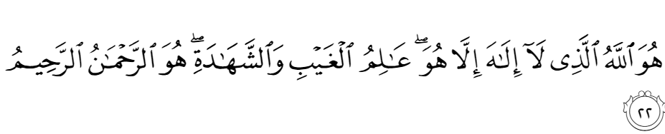

He is Allah, other than whom there is no deity, Knower of the unseen and the witnessed. He is the Entirely Merciful, the Especially Merciful.
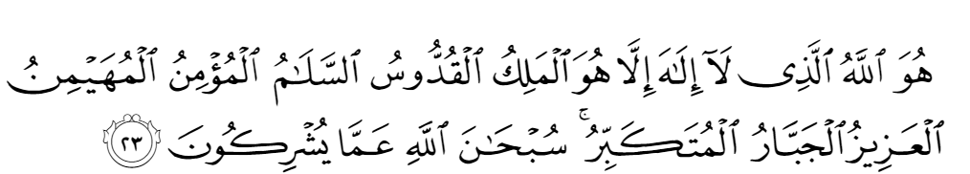

He is Allah, other than whom there is no deity, the Sovereign, the Pure, the Perfection, the Bestower of Faith, the Overseer, the Exalted in Might, the Compeller, the Superior. Exalted is Allah above whatever they associate with Him.

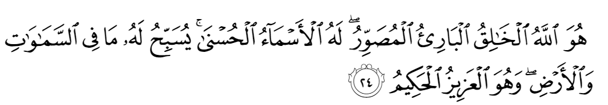 He is Allah, the Creator, the Inventor, the Fashioner; to Him belong the best names. Whatever is in the heavens and earth is exalting Him. And He is the Exalted in Might, the Wise.
Allah SWT is Al Awwal, “The First” ,before Whom there is nothing, and Al Akhir, ”The Last”, after Whom there is nothing.
He is Al Zahir,”The Outward or Manifest”, behind all the shifting scenes we perceive in this world, and Al Batil, “The Inward”, for it is His power that moves and motivates all that exists.
He is Al Khaliq, “The Creator” who gives each separate thing the light of existence by His command “Kun”, “Be”, and Al Musawwir, “The Fashioner”, who shapes it according to it’s nature and it’s purpose.
Since mankind was , as The Quraan says, ”Created Weak” or Dhaif, he is Att Tawwab “The Relenting” who never tires of turning back to his creatures when they turn to him in repentance.
He is Al Ghaffar,”The Ever Forgiving” & Al Afuw,”The Effacer of Sins”.
Whatever people do in the course of their lives, they have the opportunity to seek forgiveness so long as they have breath in their bodies….. “Oh my servants who have damaged your own selves,” says the Quraan,”despair not of the Mercy of Allah. Truly Allah pardons all sins. Truly He is Continually Forgiving & Continually Merciful. So turn unto your Lord repentant and surrender unto Him before the penalty comes upon you…”
Sinning and going astray would have no meaning if Allah SWT had not shown his creatures the right way, the Sirat ul Mustaqim or the straight path.
One of His Names is Al-Hadi, ”The Guide”. We are assured that He that He has never left any nation or any group of people without guidance. To each he has sent a Messenger to offer them a message of hope and to instruct them as to how they can, if they so wish, follow the path which leads to Jannah and and, ultimately, to the supreme goal, called Al – Ridwan, which means the “Good Pleasure” or “Satisfaction” of AllahSWT Himself. Such is the nature of this goal that the pleasure and satisfaction are reciprocal.
In Sura… V… we are told “Ya ayyatohan nafsul mutmainna, irje – ee ,ela rabbiki radiatum mardiyyah” “He is pleased with them and they are pleased with Him”
But again, the words we are obliged to use- satisfaction and pleasure are so inadequate that they can have little meaning unless accompanied by a huge leap of the imagination.
These messages have been clothed in the language and in accordance with the thought patterns of the people to whom they were addressed so as to be clear and unambiguous, and the messengers have been men like other men, although in every way better than others.
All the beautiful things we love in this world, merely reflect that Supreme Beauty.
The Prophet Mohammed SAW reported in a Hadith Qudsi “Allah is Beautiful and he loves Beauty” Akhlaq or Conduct that is in motive and in manner, beautiful, is also the best Akhlaq and the most pleasing to Allah.
But there is also the beauty of what may be called the other book, perfectly matching the Quran in its function. This is the natural world, the world of mountains and rivers, the ocean in all it’s wilderness, the trees reaching upwards and the flowers which turn to the sun; the birds too and the beasts. All Glorify their Creator “though you understand not their praise”, we are told in the Quran.
This world is a tissue of signs, of images which exist to remind us of our source and our goal. It would not be inappropriate to describe Allah SWT as the “Spinner of Images”. It is for us to read them as best we can.
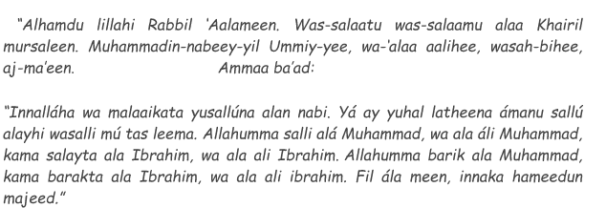
SECOND KHUTBA :
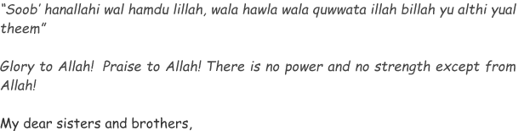
We were born out of Mercy – Rahmah – and depend upon it for our nourishment. He, Allah SWT, is “Al Razzaq”, “The Nourisher and Provider” but we must open our mouths if we are to be fed. Nothing that occurs now or in the future, however shocking it may be, can prevent any man, any woman, from achieving excellence or “Ihsaan”, if we will allow ourselves to achieve it.
Allah SWT is Al Wali, ”The Protecting Friend”, Allah SWT is no tyrant, He made as as we are, and He alone can understand us, He alone can forgive us.
“Does not your Lord suffice?”, asks the Quran, “Since He is Witness over all things?
Allah SWT is also Al Kafi, meaning “He who satisfies”. It is precisely His Witnessing that gives us sufficiency, the assurance that – whatever happens and whatever the deprivations imposed by time – nothing is lost; no longer here, it is still there in His Knowledge. Unseen yet ever present and never inattentive. He turns to us in Mercy at the very instant we turn to Him. In Quranic terms, our turning is repentance and His, is Forgiveness; we are told “And Allah SWT desires to turn to you in Mercy”
He is At Tawwab, literally “He who turns back”, usually translated as “The Ever Relenting”
Crude images and language share the limitations of our state in trying to understand Allah SWT. If they point in the right diresction, they have fulfilled their function. A dog looks expectantly at the pointing finger, but humans try to see what the finger indicates, far away in the distance. The Quran is filled with such indications. They are addressed to Yaa – kilun? “people who understand”, not to those who stop at the image and examine it under a microscope.
Allah SWT is As Salaam, “Peace” and there is no peace apart from him. He is An-Nur “Light” and even the humblest plant turns spontaneously towards the Light.
He is Al Jabbar “The Compeller” and Al Mutakabbir “The Supreme in Greatness and Sovereignty”, His Power and his Wrath are indeed to be feared, but love drives out fear, and the Quran asks: “Who else but those who have lost their way could despair of the Mercy of their Lord?”
How could we not tremble in our littleness before such Greatness? – If we have tried to follow Allah SWT’s commands as best as we can humanly, we are no longer frightened when we are drawn, as iron filings to a magnet, towards that which is Supremely Beautiful, Supremely Lovable, Supremely Desirable. Not even our sense of sin and inadequacy can hold us back when we know that Mercy and Beauty await us at journey’s end.
There is a hadith which goes somewhat like this : The Heavens, the Oceans and the Earth complained to their Creator, of mankinds wickedness and corruption.
“let me fall upon them and crush them,” pleaded the heavens,”let me engulf them and drown them”, pleaded the oceans and the earth begged permission to swallow them. But the Lord of the Worlds replied “If you had Created them, you would forgive them.”
This Khutba in its entirety gives us an idea of Allah SWT’s Mercy. When Allah SWT completed Creation He AZWJ wrote in the Book which is with Him over the Arsh, that His Mercy prevails over His Wrath.
This should give us all hope, spiritual hope & we will find Allah SWT as we think of Him, at journeys end. So if we truly think of Allah SWT as Supremely Forgiving, then that’s how we will find Him
How perfect you are O Allah, All Praise be to You and to You belong the Dominion of the heavens and Earth.
You own all the Beautiful names and through them enable us to truly know you.
We send peace and salutations on our beloved Prophet SAW.
O Allah, protect our sould from hypocrisy, our tongues from lying and our eyes from treachery.
We ask You, O Allah to have satisfiable souls that will be content with the Halaal and keep away from the haram.
Let us worship and adore You O Allah and and let us not corrupt our worship with self satisfaction.
Effect good towards Your creation by our hands, without looking for their gratitude or vainglory.
Raise us not a degree before mankind without diminishing us in our own eyesight.
No power nor strength save what comes from you.
We ask you for the best in this world and the hereafter.
Protect us from the base desires of our lower self and keep us always in the the company of those who love and fear you.
O Allah, increase us in marvelling at Your creation.
O Allah, let us be worthy of Islam,Eiman and Ihsan.
O Allah, you have said call on me and I will answer your prayers, so we have called on You so hear and answer our prayers.
May your Peace and Blessings be on the Prophet SAW, his wives, family, companions, helpers and followers
To end our Khutba,
